Exp. No: 14
ANALYSIS OF EDFA-BASED DENSE WDM LINK PERFORMANCE USING OPTISYSTEM

OBJECTIVES
- To design and simulate a Dense Wavelength Division Multiplexing (DWDM) optical communication system using OptiSystem.
- To investigate the impact of varying optical fiber length on overall system performance.
- To examine the effectiveness of an Erbium-Doped Fiber Amplifier (EDFA) in compensating for fiber attenuation losses.
- To evaluate and compare received power, bit error rate (BER), and Q-factor across different fiber lengths.
SOFTWARE REQUIRED
    - Optisystem software
BLOCK DIAGRAM
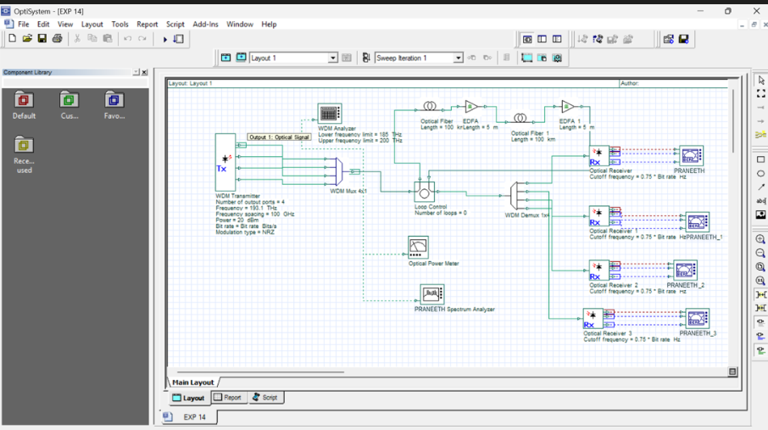
OUTPUTS
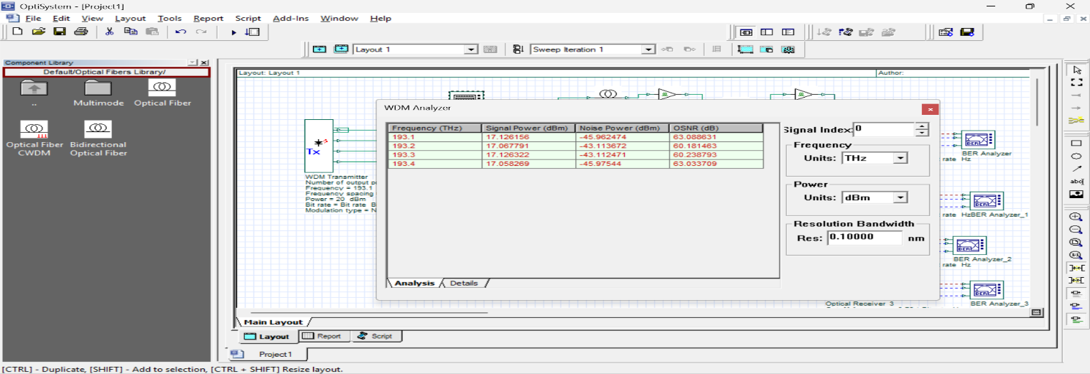
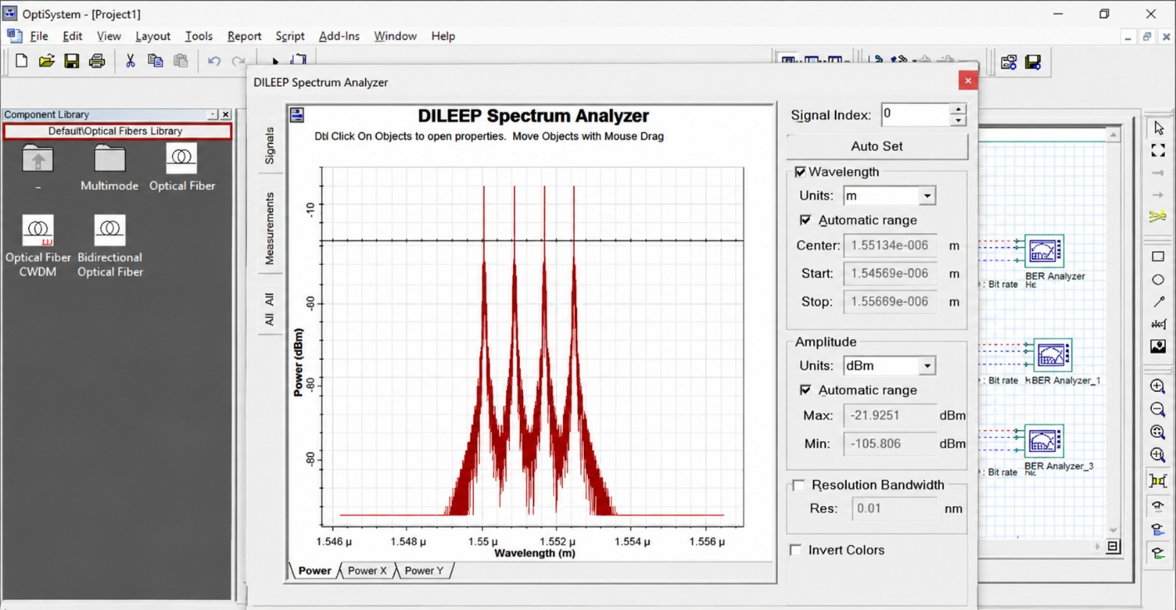

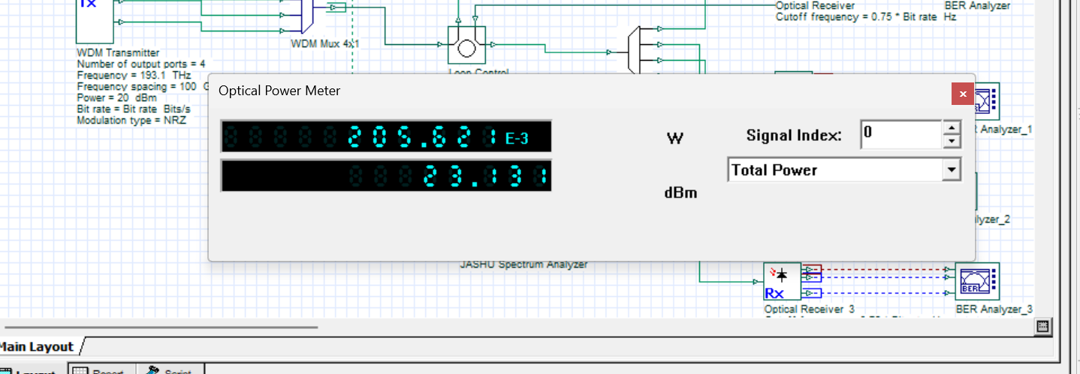

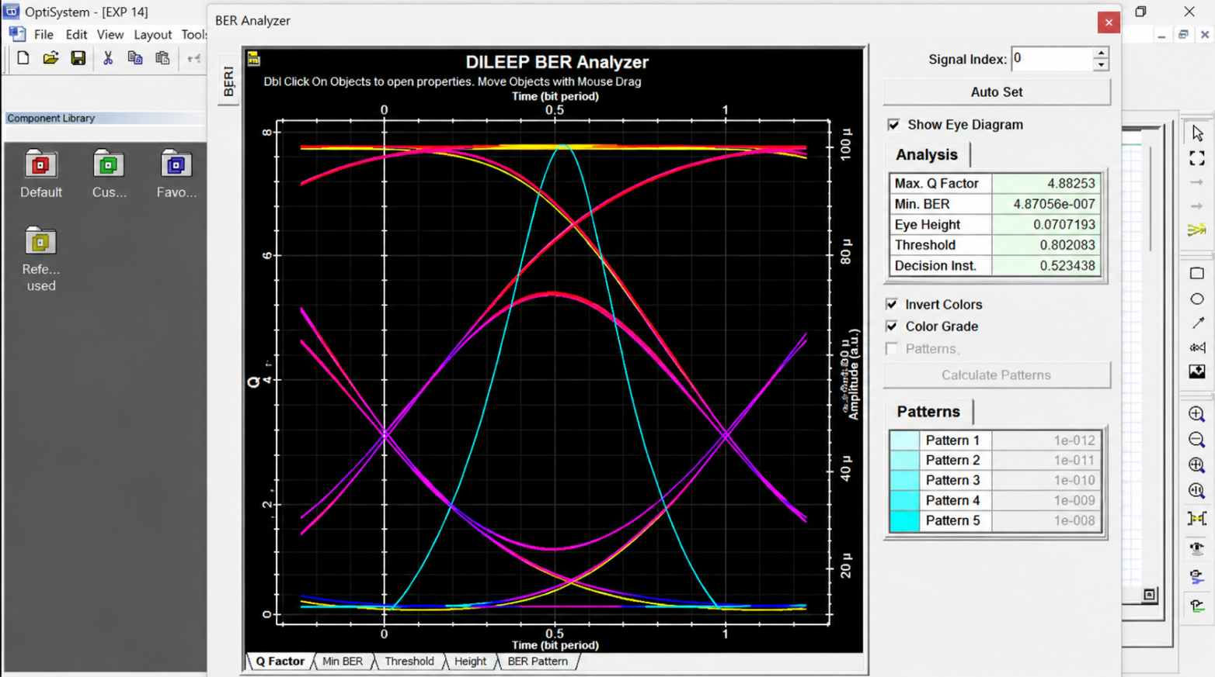

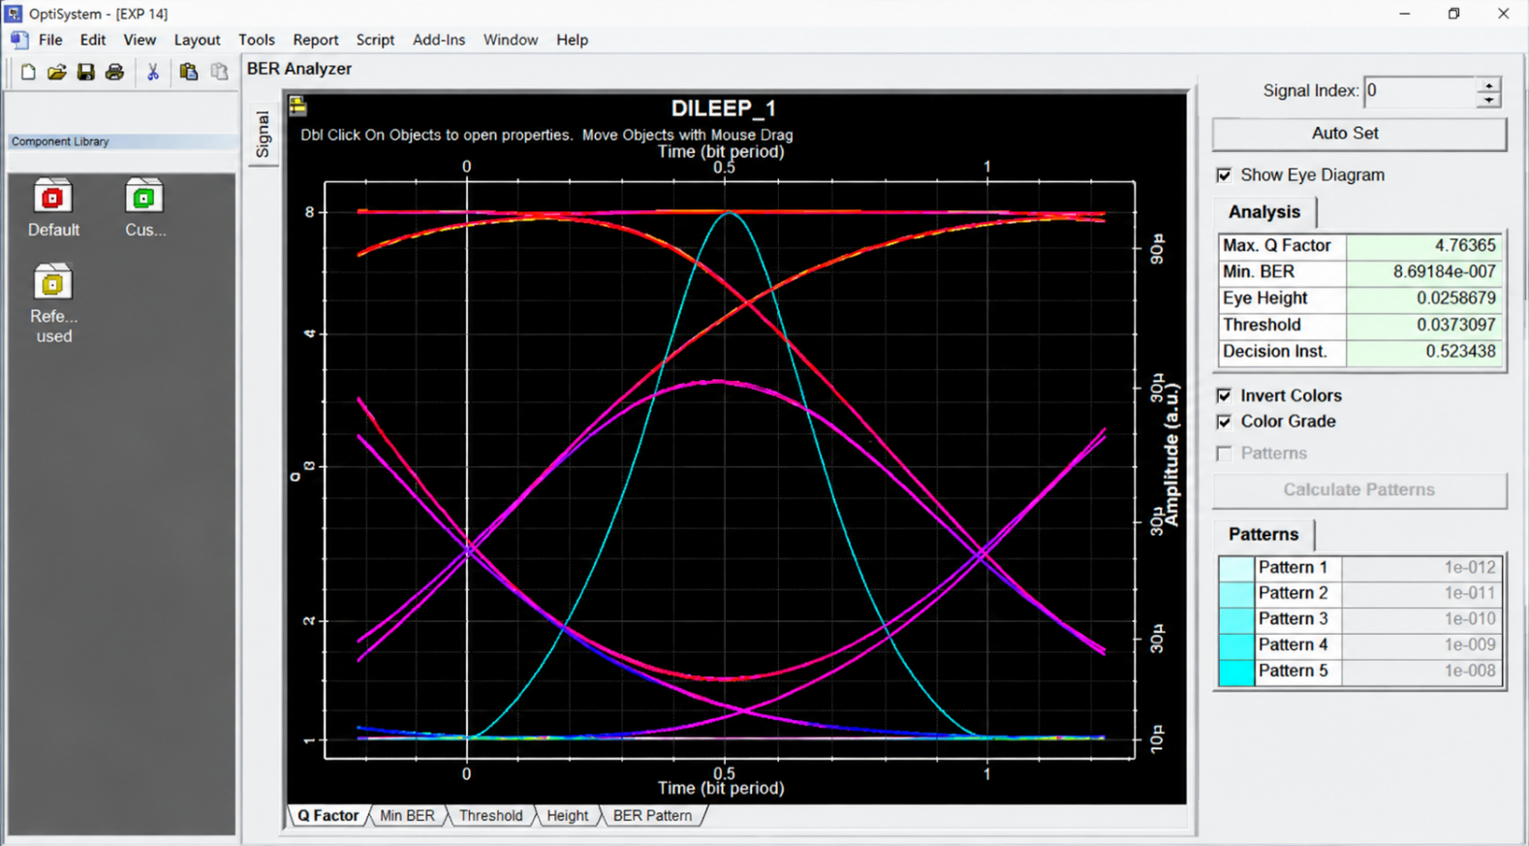

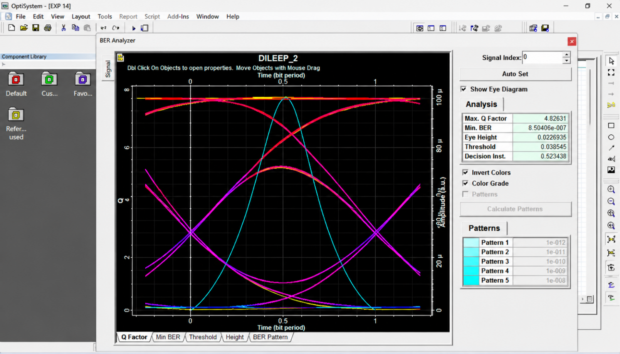

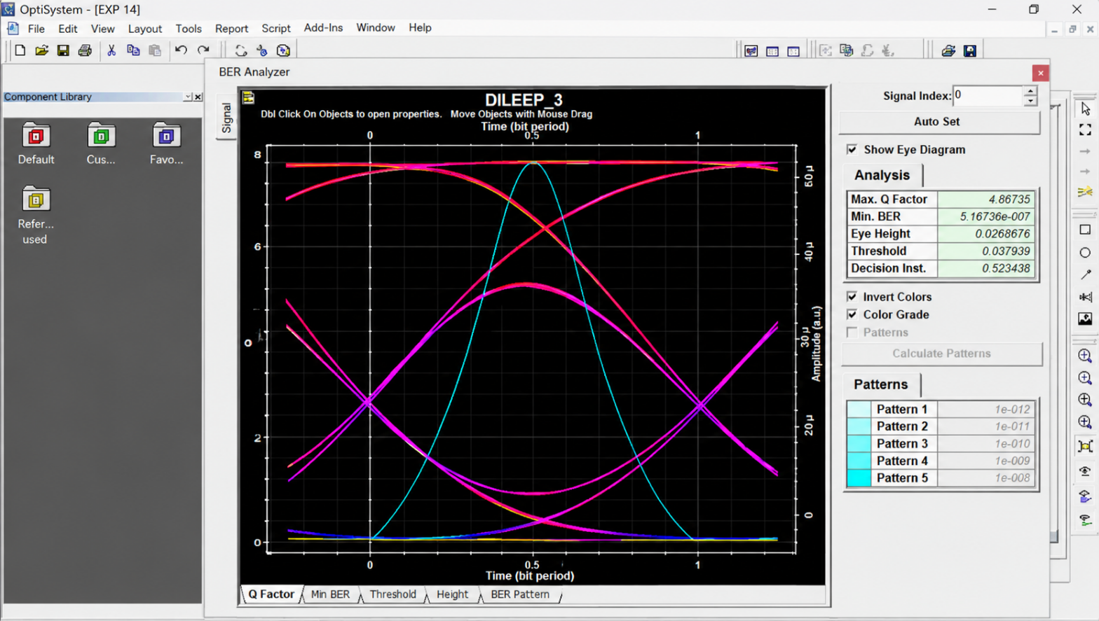

Reflection
I learned how an EDFA amplifies optical signals in a WDM communication system. I understood how optical amplifiers compensate for transmission losses and improve the performance of optical communication links.

LABORATORY PERFORMANCE ASSESSMENT RUBRIC
Objective | Assessment Criterion | Excellent – 4 | Good – 3 | Satisfactory – 2 | Needs Improvement –  1 | Weightag e
System Design | Correct selection and | All four transmitter | All components | Component | Incorrect | 20%
& DWDM | connection of | channels, | are present with | selection is | component | 20%
Setup | OptiSystem | multiplexer, fiber, | minor | partially | selection or | 20%
 | components for the | EDFA, | connection or | complete; | improper setup | 20%
 | DWDM link (PRBS | demultiplexer and | layout errors, | missing receiver | leading to | 20%
 | Generator, NRZ | receiver chains are | but the DWDM | chains or EDFA | complete | 20%
 | Pulse Generator, CW | correctly selected, | link remains | placement errors | simulation | 20%
 | Lasers, WDM | connected in | functional. | impede signal | failure. | 20%
 | Multiplexer, Optical | sequence and |  | flow. |  | 20%
 | Fiber, EDFA, WDM | configured without |  |  |  | 20%
 | Demultiplexer, PIN | errors. |  |  |  | 20%
 | Photodetectors, Low |  |  |  |  | 20%
 | Pass Filters, BER |  |  |  |  | 20%
 | Analyzers). |  |  |  |  | 20%
Parameter | Accurate setup of | All input | Test case | Basic parameters | Incorrect | 20%
Configuration | input parameters: | parameters and | parameters are | are configured, | parameter | 20%
& Execution | Transmit Power (20 | fiber-length test | mostly accurate | but multiple | settings or | 20%
 | dBm), Center | cases are accurately | with minor | fiber-length | failure to run | 20%
 | Frequency (193.1 | set and executed, | setting | cases or the | the required | 20%
 | THz), Channel | with and without | discrepancies. | with/without | test cases. | 20%
 | Spacing (100 GHz), | the EDFA. |  | EDFA |  | 20%
 | Fiber Length (50 km, |  |  | comparison are |  | 20%
 | 75 km, 100 km) and |  |  | missing. |  | 20%
 | Loop Control (0). |  |  |  |  | 20%
Measurement | Accurate extraction | Precise data | Data is collected | Partial data | Inaccurate, | 20%
& Performance | and recording of | extraction across all | with minor | collection with | incomplete or | 20%
Monitoring | Min BER, Max Q- | fiber lengths, neatly | omissions in | incomplete | missing data | 20%
 | Factor, received | tabulated with | BER, Q-factor or | tables or missing | and | 20%
 | power, optical | complete BER, Q- | power readings. | spectrum/eye | measurements. | 20%
 | spectrum and eye | factor and power |  | diagram |  | 20%
 | diagrams for all | readings and clear |  | captures. |  | 20%
 | channels and fiber | spectrum/eye |  |  |  | 20%
 | lengths. | diagrams. |  |  |  | 20%
Amplification | Detailed evaluation | Comprehensive | Clear analysis | Basic attempt at | Erroneous or | 20%
& Fiber Loss | of fiber attenuation, | analysis correctly | identifying basic | result analysis | missing | 20%
Analysis | dispersion, EDFA | relating fiber length, | trends in power, | without | analysis of | 20%
 | gain and noise, and | attenuation and | BER and Q- | explaining | simulation | 20%
 | the effect of | EDFA compensation | factor relative to | physical | results. | 20%
 | amplification on | to received power, | fiber length and | mechanisms |  | 20%
 | received power, Q- | Q-factor and BER, | EDFA use. | such as |  | 20%
 | factor and BER. | with and without |  | attenuation, |  | 20%
 |  | amplification. |  | dispersion or |  | 20%
 |  |  |  | amplifier gain. |  | 20%
Report & | Identification of the | Report features | Satisfactory | Incomplete | Disorganized | 20%
Conclusion | benefit of EDFA | clear spectra and | report with | report with | or incomplete | 20%
 | amplification, | eye diagrams, | relevant displays | missing graphs, | report lacking | 20%
 | achievable | complete result | and a sound | readings or | required | 20%
 | transmission | tables and insightful | concluding | weak | diagrams and | 20%
 | distance, trade-offs | conclusions | summary. | conclusions. | valid | 20%
 | (amplifier noise, | identifying optimal |  |  | conclusions. | 20%
 | channel spacing), | operating |  |  |  | 20%
 | structure and clarity | parameters for the |  |  |  | 20%
 | of the report. | DWDM link. |  |  |  | 20%

Result
An EDFA-based WDM optical link was studied using simulation. The role of optical amplification in signal transmission was analyzed.

